# Program on applying layout to HTML web page

## Problem Statement

Use CSS to create a responsive layout with sections like header, navigation bar, content, and footer. Apply Flexbox or Grid to control the structure of the layout.

## Steps to Solve

1. Open your code editor and create a new HTML/PHP/JS file as required.

2. Write the necessary code based on the problem statement.

3. Test the code in a web browser or PHP server to ensure it works as expected.

4. Debug any issues encountered during testing.

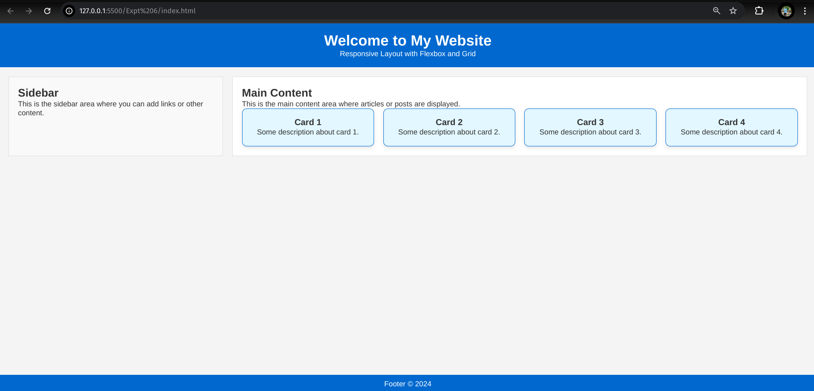5. Submit the code along with proper comments and documentation.